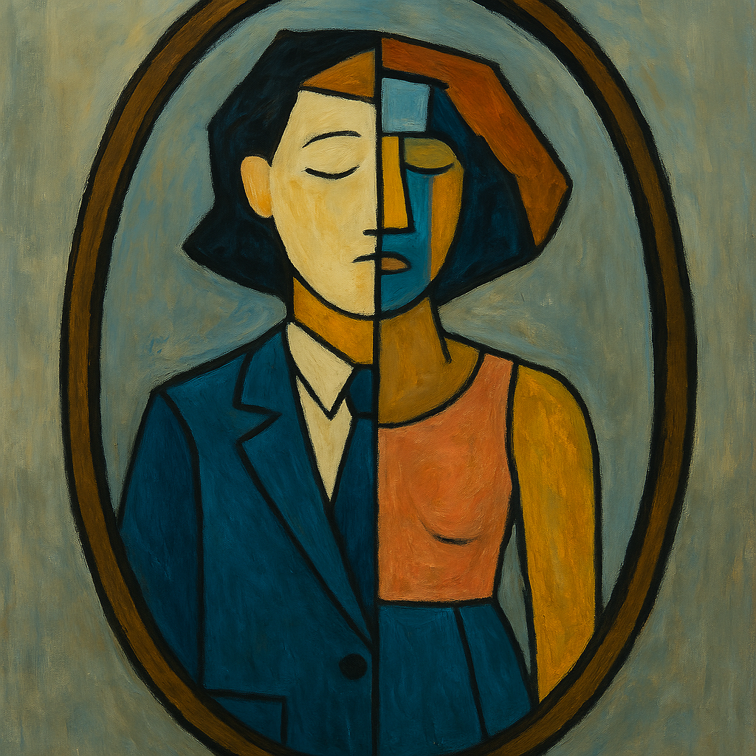

A TRANSGENDER PRAYER
By Vivian Smotherman

I was born into a riddle without answer.
I was not groomed but gifted. Not trained but tested
I was born with a flaw in my flesh—
a quiet misalignment,
a body, out of phase with my soul.
My mirror always lied.
Family photos captured a stranger where I should have been.
My childhood a monastic chant of silent begging:
“Please, make me normal.”
“Please, make it stop.”
“Please, fix me!”
Prayers eternally unanswered.
You ask so much of me.
And I have given.
Given You my beatings, my bruises, my blood, and my shame—
Through it all, I have begged You with tears, cursed You with rage.
And waited through endless silence for revelation.
In Your ineffable grace, You chose me.
Forced me to be stronger, smarter, more enduring.
You placed this weight upon my shoulders—
a burden, wrapped in a curse.
So, I will not complain.
I will not surrender.
I will not vanish to make others comfortable.
You set me between two worlds.
So I will walk in two worlds,
speak in two tongues,
and bridge the gap in understanding.
I will rescue the truths others tried to burn.
I will be a beacon for those lost in the fog.
My actions will be bold, my voice loud, my example worthy of respect.
If this is the trial You set before me,
let it be my crucible.
I will not just survive.
I will thrive.
I will carve space.
I will resurrect legacy and live loud enough to echo across time.
And when I stand before You,
in whatever world comes next,
I will not ask why You made me this way.
I only ask…

Attribution Notice
This work by Vivian Smotherman is licensed for sharing and non-commercial use—with attribution—only in ways that uplift, support, or advocate for transgender people. Misuse, misrepresentation, or appropriation for discriminatory or harmful purposes is not permitted.

